Warren 4th of July Parade and Festivities

Wednesday, July 4, 2018
For Up to the Minute Reports and photos, LIKE US on FACEBOOK.
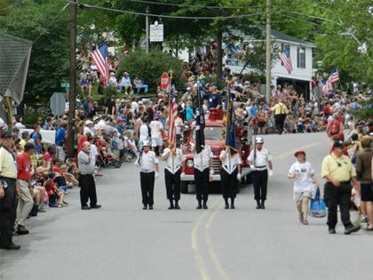For the 70th consecutive year, we celebrate our independence with a wild, wacky, and wickedly fun parade, street dance, and family festivities at the Warren 4th of July Parade and Festivities! Parade starts at 10 AM. Main Street in Warren closes at 8:30am SHARP. This event is produced by the Mad River Valley Rotary Club.
Free Shuttle Buses are running from 8am until 4pm via Sugarbush Access Rd. Satellite parking for free and FREQUENT bus pick up is at Lincoln Peak at Sugarbush. But, arrive early so as not to miss any of the fun!
There is also parking along the perimeter of Brooks Field at the Elementary School, with a short stroll down the Warren Village Path to Brook Road- right on the parade route. Access the School Rd. via East Warren Rd from Waitsfield (north), or Plunkton Rd from Granville (south).
Food Vendors are lining up, including local organic food providers like American Flatbread, Green Mtn Grillbillies, Skinny Pancake, Scout’s Honor, SamosaMan, Pingala Cafe, Graces’ Tamale, and the Yak Cart. Cornerstone Pub will host a beer and wine garden at Brooks Field (Warren Elementary School field) following the parade.
Live Music will begin following the parade- with Sklarkestra, led by Bruce Sklar and friends at the Warren Store porch for the big street dance and Mad Mountain Scramblers at Brooks Field (elementary school), a short walk from the village on the Mad River Path.
Kids’ Fun: Free, supervised kids’ activities at Brooks Field following the parade at the elementary school. Use the Warren village path from the village to the school. Events, food and music begin following the parade and last until the energy wanes.

Grand Marshal: Hannah’s House, Inc. is a local, community-supported nonprofit mental health center supporting emotional and mental health for children, teens, adults and families by providing local, high quality counseling, community outreach through education, financial assistance for psychotherapy to those in need, and alternative therapies including neuro-feedback brain training for anxiety based disorders.
The Theme: (to be determined)
Floats: No need to register. Arrive at the south end of Warren Village’s Main Street by 9am. (TIP: enter by SOUTH Main Street – south of Covered Bridge Rd – and get in line). You will be facing in the correct direction. Parade starter will put you in place as you move forward once parade begins.
Vendors: There no space remaining for 2018
NEW for 2018: Food Donation Boxes at each gate for Mad River Valley Food Shelf. Bring a non-perishable food item to donate and the Warren Church will take it to the Food Shelf!!
Fireworks: Dusk at Sugarbush Resort on Tuesday, July 4
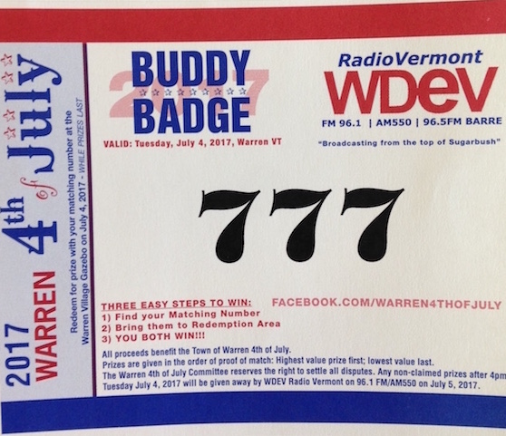
Find your Buddy and win a matching pair of prizes! Sponsored by WDEV Radio Vermont Group, help to make the day’s events free to all (parade, dance, shuttle bus, kids’ activities) with a donation of $1 or more at the gates to town. For your $1 donation you will receive a Buddy Badge numbered between 1-3000. Every badge has a match….somewhere in Warren. Find your buddy and run to the Gazebo in the village and get a pair of matching prizes donated by local merchants (while they last!). It may be a ski pass or it may be a cookie. It may even be tickets to Grace Potter’s Grand Point North show in Burlington. You’ll just have to see how lucky you are! Over $5000 in prizes will be given away, thanks to local merchants!
The Parade Boss strongly discourages bringing dogs to the parade. Please leave them home (not in the car) for the day. They won’t have nearly as much fun as you at the parade. If you MUST bring a dog, please supply adequate water and keep them leashed at all times. Please keep horses at home, too!
Sponsors: The event could not be made possible without the generous support of the taxpayers of Warren and the members of the Chamber of Commerce, along with these corporate sponsors: Waitsfield Telecom, WDEV Radio, Sugarbush Resort, Mad River Glen, Casella Waste Services, Jamieson Insurance and Karl Klein, Broker.
Events continue at Sugarbush all afternoon culminating with Fireworks at dark.
Questions should be directed HERE, or call 802-498-8545.

